Subject : We look forward to Seeing you Tomorrow!
Body Copy : As follows



Hi _______________________

We hope you are excited as much as we are excited to have you onboard with us!
Here are some details for you to take note of about the company:

Office Location: B-01-36 & B-01-37, Dataran Cascades, No.13A, Jalan PJU 5/1, Kota Damansara, 47810 Petaling Jaya, Selangor.

Dress Code: On Normal workdays - Smart Casual as most of us are always in Jeans, Sneakers and a Tee.

Getting to the Office:

Pls Waze Dataran Cascades.

It can get pretty tricky to find the office. Here are a few tips for your first day;

Parking
1) You can park in the Dataran Cascades Parking lot at LG1 or LG2 (these 2 levels consist of many reserved parking, be sure to check if the parking spot is not reserved. Failure to do so might result in your Car getting clamped with a very expensive penalty fee). This is a paid parking - max for 1 day is RM8.

2) You also park in Giant Mall which is adjacent to our office building and is FREE but you will have to walk and jump a bit, so be prepared and wear pants for this until you have mastered the art.


How to Get to Us

If you are coming from Giant,
1) Landmark: Mitraland Building; you will come across a My News outlet at level 1, Take the closest stairs or Lift to level 2.

If you are coming from LG2
Take the second lift from the front of the building to Level 2.

If you accidentally take the first lift, you will not reach us. But no worries, just give me a call and I will come to rescue you from wherever you land with the 1st Lift.

Our office’s view from outside
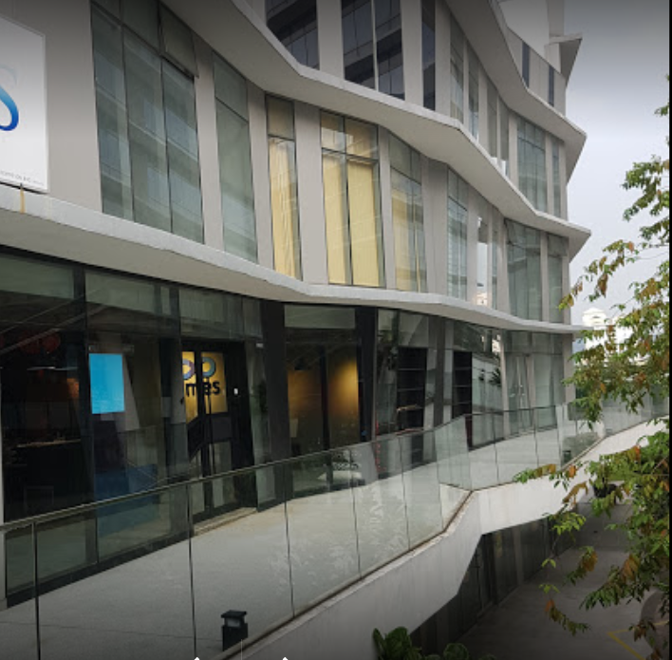

We Look forward to seeing you tomorrow!

Cheerios!
Name
Phone Number

